Critical Thinking:

**1.**

**a) List three features of every object-oriented programming language.**

Encapsulation, inheritance, and polymorphism

**b) Explain, in your own words, what you think the meaning is of each of the three features listed in part (a).**

Encapsulation is like a module.

Inheritance is like sharing information.

Polymorphism is like changing shape.

**3. Write an appropriate comment block for the beginning of a program to describe an application that is intended to calculate test averages.**

/*

This program calculates the average of test scores.

*/

**7. Explain the difference between source code and bytecode**

*LOREM IPSUM*

**8. Describe machine code.**

*LOREM IPSUM*

**11. The following application has seven syntax errors. What are they?**

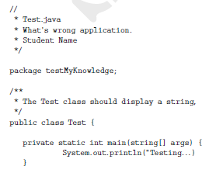

1. Lines 1 through 5 would not be commented out.
2. Not an error but there dosen’t need to be two asterisks in the line after ‘package testMyKnowledge’ ****
3. ‘testMyKnowledge’ does not have () before the semicolon.
4. ‘System.out.println(“Testing…)’ does not have a semicolon at the end.
5. ‘Testing…’ needs to be enclosed in a double quote at the end.
6. ‘main’ needs to be a public static void not a ‘private static int’.
7. There needs to be an additional curly bracket at the end of the code

**12. Explain the difference between the print() and the println() methods.**

The print() method would not start a new line to print the string whereas the println() would.

**13. Explain the advantages of using the format() method in place of the print() and println() methods.**

Format() allows you to space things by a set number of spaces. It also allows for inserting different data types into the line.